Design Plan: | Document Name: Algorithms | SWD/Form No.7
Effective Date : 08/11/2008 | Version : 1 | Page No.
1. Form Food and Buffet Manager Algorithms

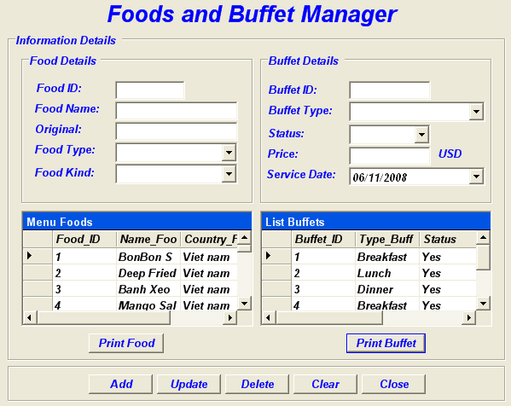

1.1 Add Buffet & Food Algorithm
Start
Show Buffet & Food Manager Form
Validate
Information
Input information
Error!
No
Check
In DataBase
Exception!
Incorrect
Yes
Insert Successful!
Correct
The End
Insert
Into DataBase

1.2 Delete Buffet & Foods Algorithm.

Start
Show Buffet & Food Manager Form
Validate
ID Input
Input ID would delete
Error!
No
Check
In DataBase
Exception!
Incorrect
Yes
Deleted Successful!
Correct
The End
Delete
From DataBase

1.3 Update Buffet & Food Algorithm.

Start
Show Buffet & Food Manager Form
Press Update Button
Check
In DataBase
Exception!
Incorrect
Update DataGrid
Successful!
Correct
The End
Loading New
DataBase

1.4 Buffet & Food Manager Print Algorithm.

Start
Show Buffet & Food Manager Form
Press Print Button
Check
Printer
Exception!
Incorrect
Print
Successful!
Correct
The End
Print
Information

2. Form Booking Buffet.

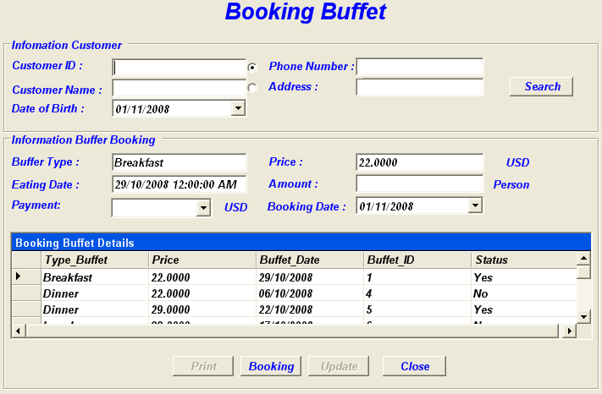

2.1 Booking Buffet Algorithm.
Start
Show Booking
Buffet Form
Validate
Information
Input Booking
Information
Error!
No
Check Information Into
DataBase
Exception!
Incorrect
Yes
Insert
Successful!
Correct
The End
Save Information
Into Database

2.2 Update Booking Buffet Algorithm.
Start
Show Booking
Buffet Form
Press Update Button
Check
In DataBase
Exception!
Incorrect
Update DataGrid
Successful!
Correct
The End
Loading New
DataBase

2.3 Print Booking Buffet Algorithm

Start
Show Booking Buffet Form
Press Print Button
Check
Printer
Exception!
Incorrect
Print
Successful!
Correct
The End
Print
Information

2.4 Search Booking Buffet Algorithm.

Start
Show Booking
Buffet Form
Validate
Informationn
Input Search
Information
Error!
No
Search Information Into
DataBase
Exception!
Incorrect
Yes
Search
Successful!
Correct
The End
Loading
Information

3. Form Buffet Order.

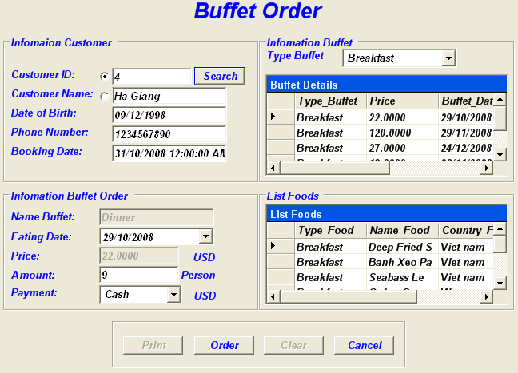

3.1 Search Buffet Order Algorithm.
Start
Show Buffet Order Form
Validate
Information
Input Search
Information
Error!
No
Search Information Into
DataBase
Exception!
Incorrect
Yes
Search
Successful!
Correct
The End
Loading
Information

3.2 Order Buffet Algorithm.
Start
Show Buffet
Order Form
Validate
Information
Input information
Error!
No
Check
In DataBase
Exception!
Incorrect
Yes
Insert
Successful!
Correct
The End
Insert
Into DataBase

3.3 Print Buffet Order Algorithm.
Start
Show Buffet
Order Form
Press Print Button
Check
Printer
Exception!
Incorrect
Print
Successful!
Correct
The End
Print
Information

4. Form Bill Buffet.

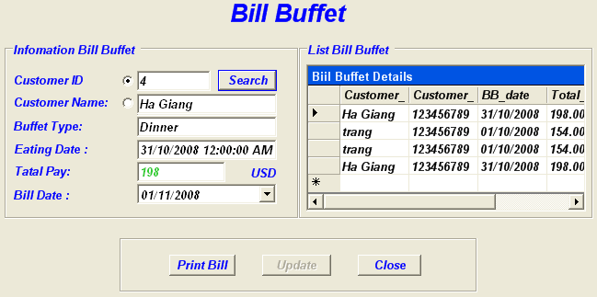

4.1 Save Bill Buffet Algorithm.
Start
Show Bill
Buffet Form
Validate
Information
Input information
Error!
No
Check
In DataBase
Exception!
Incorrect
Yes
Save
Successful!
Correct
The End
Save Data
Into DataBase

4.2 Update DataGrid Bill Buffet algorithm.

Start
Show Bill
Buffet Form
Press Update Button
Check
In DataBase
Exception!
Incorrect
Update DataGrid
Successful!
Correct
The End
Loading New
DataBase

4.3 Print Bill Buffet Algorithm.

Start
Show Bill
Buffet Form
Press Print Button
Check
Printer
Exception!
Incorrect
Print
Successful!
Correct
The End
Print
Information

4.4 Search Bill Buffet Algorithm.

Start
Show Bill
Buffet Form
Validate
Information
Input Search
Information
Error!
No
Search Information Into
DataBase
Exception!
Incorrect
Yes
Search
Successful!
Correct
The End
Loading
Information

5. Form Bussiness Report.

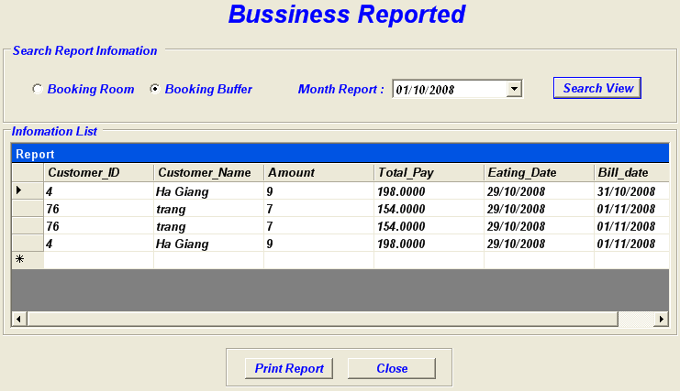

5.1 Print Business Report algorithm.

Start
Show Business
Report Form
Press Print Button
Check
In Database
Exception!
Incorrect
Report
Successful!
Correct
The End
Loading
Report Information

5.2 Search Business Report algorithm.
Start
Show Business
Report Form
Validate
Information
Input Search
Information
Error!
No
Search Information Into
DataBase
Exception!
Incorrect
Yes
Search
Successful!
Correct
The End
Loading
Information

6. From check out.

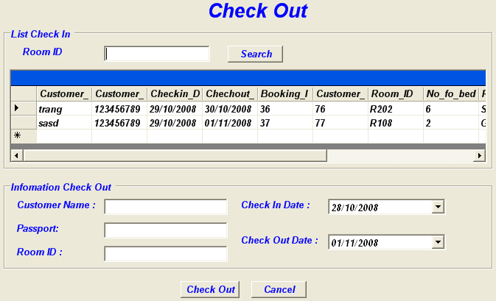

6.1 CheckOut Algorithm.
Display Check out Form
True
False
True
Choice a row on data grid which display of information customer on form
The process from
List check in customer on DataGrid

False
Display Successful
Message
Save Information
Into Database
Display Error!
End
Start
Check Input
Information

7. Login form.

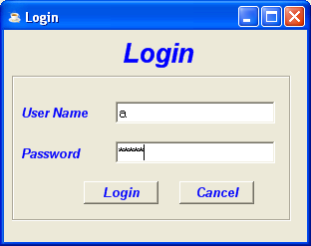

7.1 Login Algorithmt.
Start

Display Login Form

Input information in form
Successful message
End
Check Information Inputted
Check data in database
False
True
False
True

Error message

Error message

7. Form User manager.

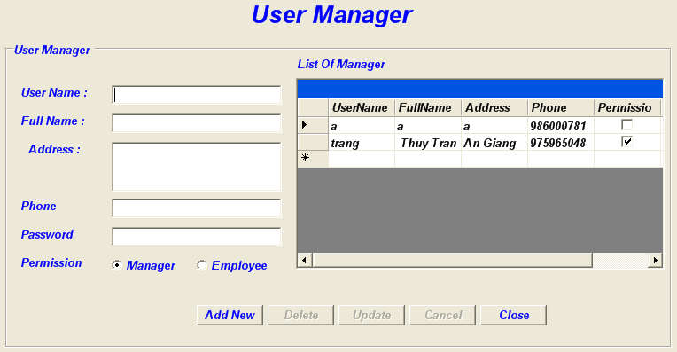

7.1 Add New Algorithmt.

Begin

Display User Manager Form

Input information

Error Message!

Check Information
False

True
Save
To Database

Display information on DataGrid

Completed Message

End

7.2 Delete Algorithmt.

Begin

Display User Manager From

Select User to delete on DataGrid

Check in
DataBase

Error Message!

False

True
Deleted to database

Update DataGird

Completed Message

End

7.3 Update Algorithm.
Begin

Display User Manager From

Select User to update on DataGrid

Edit information of User

False
Error Message

Check information

True
Save update to database

Update DataGrid

Completed Message

End

8. Form Customer.

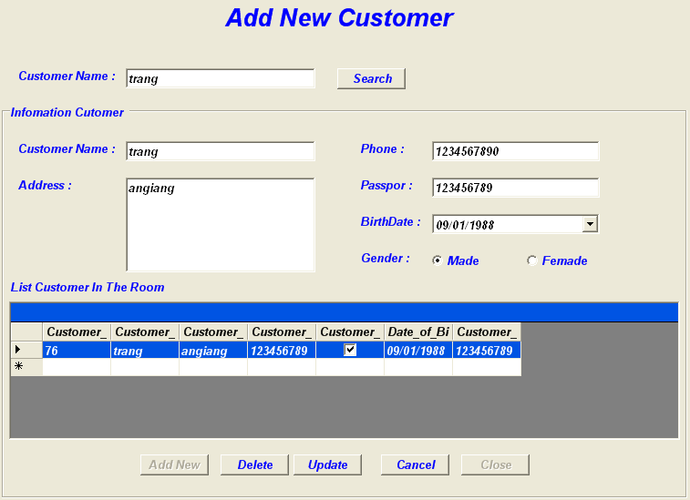

8.1 Add New Algorithm.
Begin

Display Customer Form

Input information

Error! Message

Check Information
False

True

Save
To Database

Display Information on DataGrid

Completed Message

End

8.2 Update Algorithm.
Begin

Display Customer From

Select Customer to update on data grid

Edit information of Customer

Check Input information

False
Error Message

True
Save update to database

Loading on DataGrid

Completed Message

End

8.3 Delete Algorithm.
Begin

Display Customer From

False

Select Customer to delete on DataGrid

Check Input information

Error Message!

True
Deleted to database

Update on DataGrid

Completed Message

End

9. Form Search Room.

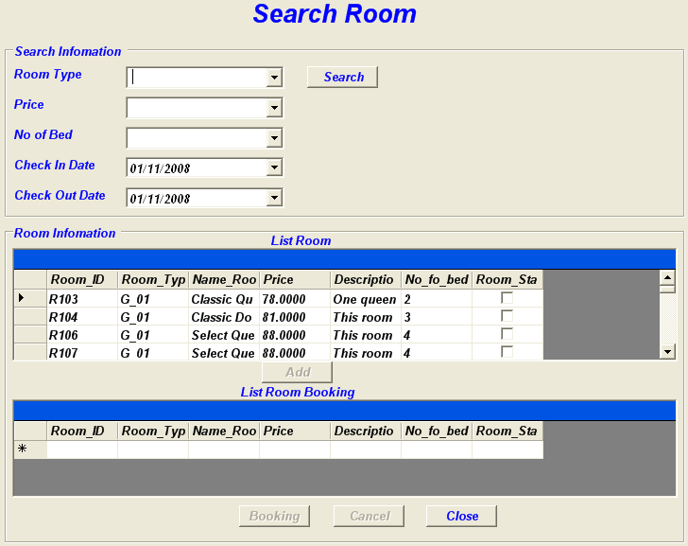

9.1 SEARCH ROOM Algoritmt.

Begin
Display form Search Room on screen
Test database
Display All Rooms available
End
Access to database
Y
N

Select information need to Search

Message not Found!

Input information need to search: Room Type, Price, No Of Bed.
- Access to database: query in database to search all rooms is correct.
- Display all room available.
- Message No Found: Display message to show not room available with condition and required user input again

10. Form Booking Room.

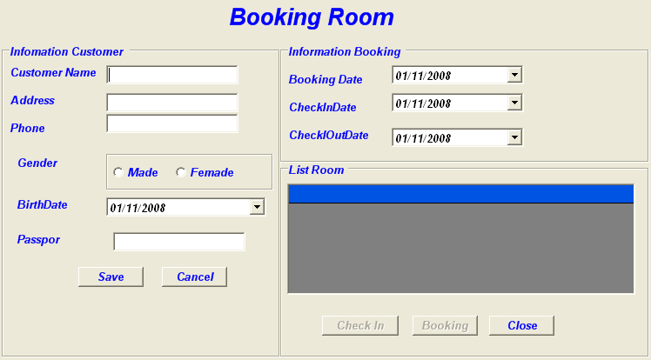

10.1 BOOKING ROOM Algorithmts.

Begin

Display form Booking Room on screen

Input information in form Booking Room

Test Information
N
Message error!

Y

Save on database

Message complete!

Choice Room in Datagrip needs Book

Click button Booking

Message complete

End

- Input information in form booking room
- Test information input in form.
- Insert values in tables on database incustomer table.
- Message display complete message.
- Choice Room in Datagrip needs Booking.
- Click Button Booking .
Message display complete message

11. Form Check in Room.

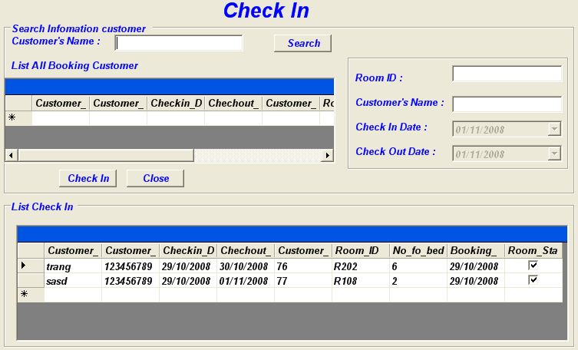

11.1 CHECK IN Algorithmts.
Begin
Display form Booking,Check In Room on screen
Input information Customer in form Booking,Check In Room
Message error!
Test Validate
N
Y
Save on database
Message complete

Choice day booking,checkin,check out in From Booking Room

Choice Room in Datagrip needs Booking or Check In

Click button Booking or Check In

Message complete

End

12. From Change Room:

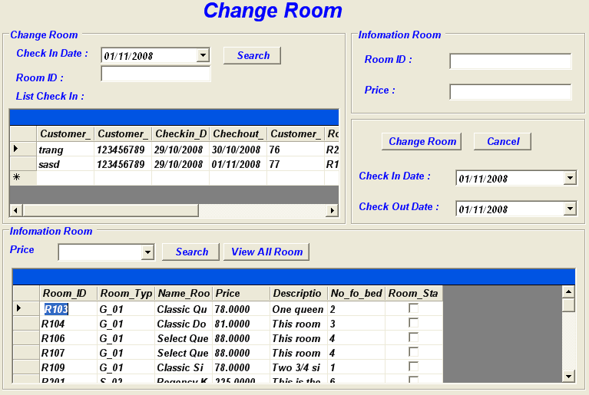

12.1 Change Room Algorithmt.
Begin

Display form Check In on screen

Search Date CheckIn and RoomID in DataGrid

Search Price Room available needs Change in DataGrid

Message Error!

Test Room
N

Y
Save Database

Show Message successful

End

 | Prepared By (Student) | Approved By (Teacher)
Date: | Group IV | Tran Thi Hong An

